Margarita Gokun Silver (b. 1969, Russia)
Artist/Writer
Madrid, Spain
| www.MargaritaGokunSilver.com| @MGokunArt |

Exhibitions
2017 In Spanglish, Casa Sefarad, Madrid, Spain (group)
2015 Tomorrow Dreams, Factoria de Babel, Majadahonda, Spain (group)
2015 Dreaming the dream that’s dreaming you, Donde Chelo, Madrid, Spain (solo)
2014 Sueños, Amor al Arte, Cuenca, Spain (solo)
2011 Be Inspired, Museum of Fine Arts, Ft. Lauderdale, FL, USA (group)

Bibliography (paintings published in following magazines)
At Length magazine, May 2017
TRIVIA magazine, April 2013
Line Zero magazine, EDITOR’S CHOICE, Summer 2013
Switchback magazine, University of San Francisco, Fall 2013
Flyway magazine, University of Iowa, April 2014
ROPES2014 magazine, National University of Ireland, Galway, April 2014
Empty Mirror magazine, December 2014

Social Media Mentions

Deepak Chopra tweeted one of my paintings to all of his followers with a note “I love this” (image of tweet below)
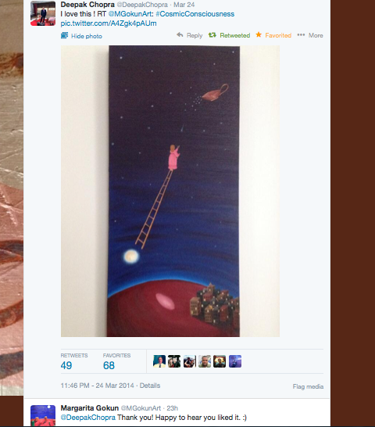

Collections
Works held in private collections in Canada, the United States, and Spain.

